Discussion 6.1_Team Application
Poorly Written Document
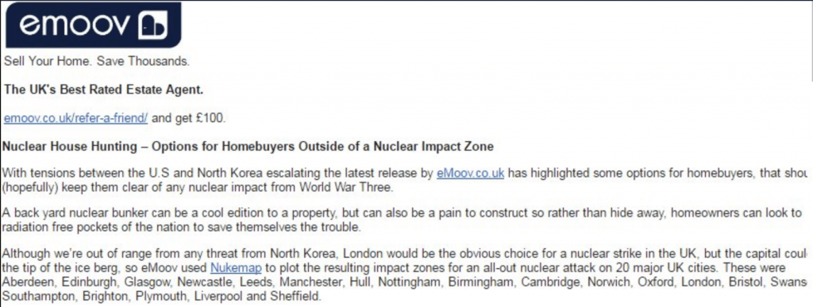
Improved document
Emoov
Sell Your Home and Save Thousands.
The UK’s Best Rated Estate Agent.
Emoov.co.uk/refer-a-friend/ and get £100.
Nuclear House Hunting- Options for Homebuyers Outside a Nuclear Impact Zone.
Following the escalating tensions between the U.S and North Korea, emoov highlighted some options for homebuyers that should keep them away from any nuclear impact from World War Three.
A backyard nuclear bunker can be a cool edition to a property. This option can also be hard to construct. Homeowners can save themselves from this trouble by incorporating radiation-free pockets.
London can still be a choice for nuclear strike in the UK even though it is believed that it is out of range from any threat from North Korea. The results from Nukemap reveals that most cities fall under the impact zone of this war. These cities include Aberdeen, Edinburgh, Glasgow, Newcastle, and Sheffield, among others.
Track of Improvement by each Group Member
First Member: The first group member addressed the clarity of the document. The member addressed this issues by using passive voice appropriately. He addressed this sentence, “emoov highlighted some options for homebuyers that should keep them away from any nuclear impact from World War Three.” The above sentence is clear because it is direct to the point.
Second Member: The second member worked on the conciseness of the document. He removed the wordy sentences and replaced them with short ones. “Following the escalating tensions between the U.S and North Korea, emoov highlighted some options for homebuyers that should keep them away from any nuclear impact from World War Three.”
Third Member: worked on Fluency of the document. For instance, he combined very short sentences that were meaningless to form fluent sentence. “Sell Your Home and Save Thousands.” He also corrected the poorly used punctuation marks such as comas in the document.
Fourth Sentence: The fourth member focused on the personable aspect of the document. He removed the biased languages in this document. Some of the biased languages include. “London would be the obvious choice for nuclear choice in UK.” This sentence was changed to unbiased language, “London can still be a choice for nuclear strike in the UK.”

